Summary report of mean, median, mode:

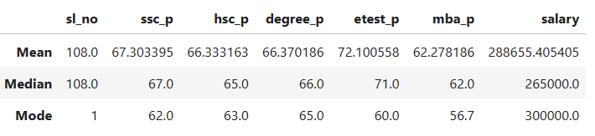

**Mean:**

* The average SSC score is approximately 67.3%
* The average HSC score and degree is same as approximately 66.3%, which is slightly lower than SSC
* The average E test is approximately 72.1% which is the highest performance mean
* The average MBA score is approximately 62.27, which is lowest mean among all academics.
* Students average salary is higher than median salary as 288655.405

**Median:**

* + The median of SSC score is 67.0
  + The median of HSC score is 65.0
  + The median of degree score is 66.0
  + The median of E test score is 71.0
  + The median of MBA score is 62.0
  + The median of Salary is 265000

**Mode:**

* + The most common score of SSC is 62.0
  + The most common score of HSC is 63.0
  + The most common score of degree is 65.0
  + The mode of E test score is 60.0
  + The mode of MBA score is 56.7
  + The most common salary in the dataset is 300000